ISYE 6740 – Midterm 1

Nicholas Chao – [nchao3@gatech.edu](mailto:nchao3@gatech.edu)

1. **K-Means**

Euclidean Distance between two vectors, $x_{1}$ and $x_{2}$: $\sqrt{\sum{{\left(x_{1}-x_{2}\right)}^{2}}}$

Manhattan Distance between two vectors, $x_{1}$ and $x_{2}$: $\sum{\left|x_{1}-x_{2}\right|}$

Geometric Mean of set of $N$ vectors: $\frac{\sum_{n}^{N}{x_{n}}}{N}$

Initial Centroid A: $(-3, -1)$

Initial Centroid B: $(2, 1)$

**Using Euclidean Distance:**

1. Datapoint 1 -> Cluster B

Datapoint 2 -> Cluster A

Datapoint 3 -> Cluster B

Datapoint 4 -> Cluster B

Datapoint 5 -> Cluster A

Datapoint 1: $(2, 2)$

Distance from A: $\sqrt{\sum{{\left(\left(2, 2\right)-\left(-3, -1\right)\right)}^{2}}}= \sqrt{\sum{{\left(5, 3\right)}^{2}}}=\sqrt{\sum{\left(25, 9\right)}}=\sqrt{34}=5.83$

Distance from B: $\sqrt{\sum{{\left(\left(2, 2\right)-\left(2, 1\right)\right)}^{2}}}= \sqrt{\sum{{\left(0, 1\right)}^{2}}}=\sqrt{\sum{\left(0, 1\right)}}=\sqrt{1}=1$

Datapoint 2: $(-1, 1)$

Distance from A: $\sqrt{\sum{{\left((-1, 1)-\left(-3, -1\right)\right)}^{2}}}= \sqrt{\sum{{\left(2, 1\right)}^{2}}}=\sqrt{\sum{\left(4, 1\right)}}=\sqrt{5}=2.24$

Distance from B: $\sqrt{\sum{{\left((-1, 1)-\left(2, 1\right)\right)}^{2}}}= \sqrt{\sum{{\left(-3, 0\right)}^{2}}}=\sqrt{\sum{\left(9, 0\right)}}=\sqrt{9}=3$

Datapoint 3: $(3, 1)$

Distance from A: $\sqrt{\sum{{\left((3, 1)-\left(-3, -1\right)\right)}^{2}}}= \sqrt{\sum{{\left(6, 2\right)}^{2}}}=\sqrt{\sum{\left(36, 4\right)}}=\sqrt{40}=6.32$

Distance from B: $\sqrt{\sum{{\left((3, 1)-\left(2, 1\right)\right)}^{2}}}= \sqrt{\sum{{\left(1, 0\right)}^{2}}}=\sqrt{\sum{\left(1, 0\right)}}=\sqrt{1}=1$

Datapoint 4: $(0, -1)$

Distance from A: $\sqrt{\sum{{\left((0, -1)-\left(-3, -1\right)\right)}^{2}}}= \sqrt{\sum{{\left(3, 0\right)}^{2}}}=\sqrt{\sum{\left(9, 0\right)}}=\sqrt{9}=3$

Distance from B: $\sqrt{\sum{{\left((0, -1)-\left(2, 1\right)\right)}^{2}}}= \sqrt{\sum{{\left(-2, -2\right)}^{2}}}=\sqrt{\sum{\left(4, 4\right)}}=\sqrt{8}=2.83$

Datapoint 5: $(-2, -2)$

Distance from A: $\sqrt{\sum{{\left((-2, -2)-\left(-3, -1\right)\right)}^{2}}}= \sqrt{\sum{{\left(1, -1\right)}^{2}}}=\sqrt{\sum{\left(1, 1\right)}}=\sqrt{2}=1.41$

Distance from B: $\sqrt{\sum{{\left((-2, -2)-\left(2, 1\right)\right)}^{2}}}= \sqrt{\sum{{\left(-4, -3\right)}^{2}}}=\sqrt{\sum{\left(16, 9\right)}}=\sqrt{25}=5$

1. Cluster A’s centroid becomes (-1.5, -0.5)

Cluster B’s centroid becomes (1.667, 0.667)

Cluster A: $\left\{\left(-1, 1\right);\left(-2, -2\right)\right\}$

Geometric Mean: $\frac{\sum_{n}^{N}{x_{n}}}{N}=\frac{\left(-1, 1\right)+\left(-2, -2\right)}{2}=\frac{\left(-3, -1\right)}{2}=\left(-1.5, -0.5\right)$

Cluster B: $\left\{\left(2, 2\right);\left(3, 1\right);\left(0,-1\right)\right\}$

Geometric Mean: $\frac{\sum_{n}^{N}{x_{n}}}{N}=\frac{\left(2, 2\right)+\left(3, 1\right)+\left(0,-1\right)}{3}=\frac{\left(5, 2\right)}{3}=\left(1.667, 0.667\right)$

1. The algorithm **will not** terminate after one step. Another iteration will result in the follow clusters:

Datapoint 1 -> Cluster B

Datapoint 2 -> Cluster A

Datapoint 3 -> Cluster B

Datapoint 4 -> Cluster A

Datapoint 5 -> Cluster A

Datapoint 1: $(2, 2)$

Distance from A: 4.30

Distance from B: $1.37$

Datapoint 2: $(-1, 1)$

Distance from A: $1.58$

Distance from B: $2.69$

Datapoint 3: $(3, 1)$

Distance from A: $4.74$

Distance from B: $1.37$

Datapoint 4: $(0, -1)$

Distance from A: $1.58$

Distance from B: $2.36$

Datapoint 5: $(-2, -2)$

Distance from A: $1.58$

Distance from B: $4.53$

**Using Manhattan Distance:**

1. Datapoint 1 -> Cluster B

Datapoint 2 -> Cluster B

Datapoint 3 -> Cluster B

Datapoint 4 -> Cluster A

Datapoint 5 -> Cluster A

Datapoint 1: $(2, 2)$

Distance from A: $\sum{\left|\left(2, 2\right)-\left(-3, -1\right)\right|}= \sum{\left|\left(5, 3\right)\right|}=\sum{\left(5, 3\right)}=8$

Distance from B: $\sum{\left|\left(2, 2\right)-\left(2, 1\right)\right|}= \sum{\left|\left(0, 1\right)\right|}=\sum{\left(0, 1\right)}=1$

Datapoint 2: ($-1, 1)$

Distance from A: $\sum{\left|\left(-1, 1\right)-\left(-3, -1\right)\right|}= \sum{\left|\left(2, 2\right)\right|}=\sum{\left(2, 2\right)}=4$

Distance from B: $\sum{\left|\left(-1, 1\right)-\left(2, 1\right)\right|}= \sum{\left|\left(-3, 0\right)\right|}=\sum{\left(3, 0\right)}=3$

Datapoint 3: ($3, 1)$

Distance from A: $\sum{\left|\left(3, 1\right)-\left(-3, -1\right)\right|}= \sum{\left|\left(6, 2\right)\right|}=\sum{\left(6, 2\right)}=8$

Distance from B: $\sum{\left|\left(3, 1\right)-\left(2, 1\right)\right|}= \sum{\left|\left(1, 0\right)\right|}=\sum{\left(1, 0\right)}=1$

Datapoint 4: (0 $, -1)$

Distance from A: $\sum{\left|\left(0, -1\right)-\left(-3, -1\right)\right|}= \sum{\left|\left(3, 0\right)\right|}=\sum{\left(3, 0\right)}=3$

Distance from B: $\sum{\left|\left(0, -1\right)-\left(2, 1\right)\right|}= \sum{\left|\left(-2, -2\right)\right|}=\sum{\left(2, 2\right)}=4$

Datapoint 5: (-2 $, -2)$

Distance from A: $\sum{\left|\left(-2, -2\right)-\left(-3, -1\right)\right|}= \sum{\left|\left(1, -2\right)\right|}=\sum{\left(1, 1\right)}=2$

Distance from B: $\sum{\left|\left(-2, -2\right)-\left(2, 1\right)\right|}= \sum{\left|\left(-4, -3\right)\right|}=\sum{\left(4, 3\right)}=7$

1. Cluster A’s centroid becomes (-1, -1.5)

Cluster B’s centroid becomes (1.33, 1.33)

Cluster A: $\left\{\left(0, -1\right);\left(-2, -2\right)\right\}$

Geometric Mean: $\frac{\sum_{n}^{N}{x_{n}}}{N}=\frac{\left(0 ,- 1\right)+\left(-2, -2\right)}{2}=\frac{\left(-2, -3\right)}{2}=\left(-1, -1.5\right)$

Cluster B: $\left\{\left(2, 2\right);\left(-1, 1\right);\left(3,1\right)\right\}$

Geometric Mean: $\frac{\sum_{n}^{N}{x_{n}}}{N}=\frac{\left(2, 2\right)+\left(-1, 1\right)+\left(3,1\right)}{3}=\frac{\left(4, 4\right)}{3}=\left(1.33, 1.33\right)$

1. The algorithm **will not** terminate after one step. Another iteration will result in the follow clusters:

Datapoint 1 -> Cluster B

Datapoint 2 -> Cluster A

Datapoint 3 -> Cluster B

Datapoint 4 -> Cluster A

Datapoint 5 -> Cluster A

Datapoint 1: $(2, 2)$

Distance from A: 6.5

Distance from B: $1.33$

Datapoint 2: $(-1, 1)$

Distance from A: $2.5$

Distance from B: $2.67$

Datapoint 3: $(3, 1)$

Distance from A: $6.5$

Distance from B: $2$

Datapoint 4: $(0, -1)$

Distance from A: $1.5$

Distance from B: $3.67$

Datapoint 5: $(-2, -2)$

Distance from A: $1.5$

Distance from B: $6.67$

1. **Spectral Clustering (R code is included separately in Q2.R)**

Give the following labels for each point in the data:

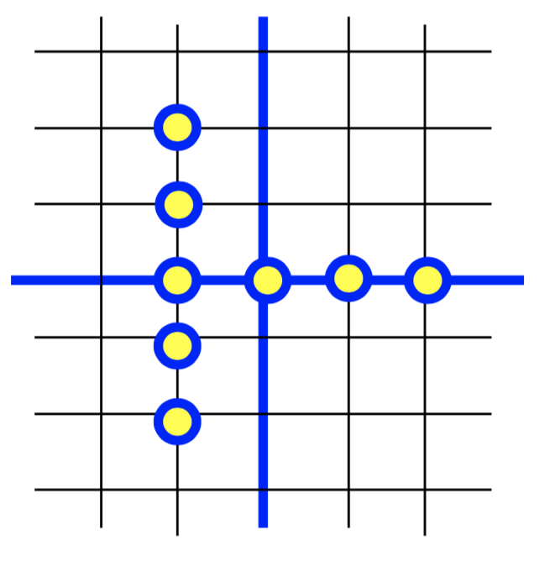

8

7

6

5

4

3

1

2

The nearest-neighbor embedding will result in the following graph:

1

4

8

7

6

5

3

2

Edge weights are then calculated by:

$$W_{ij}=exp\left(-\left\|x_{i}-x_{j}\right\|\right)$$

Using the above weight formula, the following Adjacency matrix for the neighborhood graph is built:

$$\left[\begin{matrix}0 & 0.3678794 & 0.1353353 & 0 & 0 & 0 & 0 & 0 \\ 0.3678794 & 0 & 0.3678794 & 0 & 0 & 0 & 0 & 0 \\ 0.1353353 & 0.3678794 & 0 & 0.3678794 & 0.1353353 & 0.3678794 & 0 & 0 \\ 0 & 0 & 0.3678794 & 0 & 0.3678794 & 0 & 0 & 0 \\ 0 & 0 & 0.1353353 & 0.3678794 & 0 & 0 & 0 & 0 \\ 0 & 0 & 0.3678794 & 0 & 0 & 0 & 0.3678794 & 0.1353353 \\ 0 & 0 & 0 & 0 & 0 & 0.3678794 & 0 & 0.3678794 \\ 0 & 0 & 0 & 0 & 0 & 0.1353353 & 0.3678794 & 0\end{matrix}\right]$$

Where each row and column correspond to each of the 8 datapoints in order.

For example, $A_{21}=0.3678794$ because $X_{2}=\left\{-1, 1\right\}$ and $X_{1}=\left\{-1, 2\right\}$. Therefore,

$$W_{21}=exp\left(-\left\|x_{2}-x_{1}\right\|\right)=exp\left(-\left\|\left\{-1, 1\right\}-\left\{-1, 2\right\}\right\|\right)=exp\left(-1\right)=0.3678794$$.

Similarly, $A_{31}=0.1353353$ because $X_{3}=\left\{-1, 0\right\}$ and $X_{1}=\left\{-1, 2\right\}$. Therefore,

$W_{31}=exp\left(-\left\|x_{3}-x_{1}\right\|\right)=exp\left(-\left\|\left\{-1, 0\right\}-\left\{-1, 2\right\}\right\|\right)=exp\left(-2\right)=0.1353353$.

These calculations were done for each datapoint that shared an edge in the neighborhood graph to build the adjacency matrix.

The Degree matrix is then built, using $D_{ii}=\sum_{e}^{E}{W_{ie}}$ where $E$ represents all the edges of node $i$. This results in the following matrix:

$$\left[\begin{matrix}0.5032147 & 0 & 0 & 0 & 0 & 0 & 0 & 0 \\ 0 & 0.7357589 & 0 & 0 & 0 & 0 & 0 & 0 \\ 0 & 0 & 1.374309 & 0 & 0 & 0 & 0 & 0 \\ 0 & 0 & 0 & 0.7357589 & 0 & 0 & 0 & 0 \\ 0 & 0 & 0 & 0 & 0.5032147 & 0 & 0 & 0 \\ 0 & 0 & 0 & 0 & 0 & 0.8710942 & 0 & 0 \\ 0 & 0 & 0 & 0 & 0 & 0 & 0.7357589 & 0 \\ 0 & 0 & 0 & 0 & 0 & 0 & 0 & 0.5032147\end{matrix}\right]$$

For example, $D_{11}=0.5032147$ because Node $1$ has edges with Nodes $2$ and $3$, with weights $0.3678794$ and $0.1353353$, respectively. These weights sum up to $0.5032147$ to give that node’s weighted degree.

The Laplacian is then calculated as $L=D-A$. This gives the following Laplacian matrix:

$$\left[\begin{matrix}0.5032147 & -0.3678794 & -0.1353353 & 0 & 0 & 0 & 0 & 0 \\ -0.3678794 & 0.7357589 & -0.3678794 & 0 & 0 & 0 & 0 & 0 \\ -0.1353353 & -0.3678794 & 1.374309 & -0.3678794 & -0.1353353 & -0.3678794 & 0 & 0 \\ 0 & 0 & -0.3678794 & 0.7357589 & -0.3678794 & 0 & 0 & 0 \\ 0 & 0 & -0.1353353 & -0.3678794 & 0.5032147 & 0 & 0 & 0 \\ 0 & 0 & -0.3678794 & 0 & 0 & 0.8710942 & -0.3678794 & -0.1353353 \\ 0 & 0 & 0 & 0 & 0 & -0.3678794 & 0.7357589 & -0.3678794 \\ 0 & 0 & 0 & 0 & 0 & -0.1353353 & -0.3678794 & 0.5032147\end{matrix}\right]$$

The eigen-decomposition is then found for this Laplacian. This results in the following Eigenvalues and corresponding Eigenvectors:

Eigenvalues:

$$\left\{1.798349, 1.160359, 1.005303, 0.9183616, 0.7302276, 0.2336702, 0.160535, 0\right\}$$

Eigenvectors (represented at $p×k$ matrix where $p$ is number of dimensions of eigenvectors and $k$ is the number of eigenvectors):

$$\left[\begin{matrix}-0.005624343 & 0.09854295 & 0.4179216 & 0.4231428 & -0.29717638 & 0.5703872 & 0.3128803 & 0.3535534 \\ -0.283299265 & -0.24291919 & -0.5703872 & -0.3937439 & 0.07365058 & 0.4179216 & 0.2743595 & 0.3535534 \\ 0.823911178 & 0.18183020 & 3.941292e-15 & -0.2277019 & 0.29828377 & 2.498002e-16 & 0.1492877 & 0.3535534 \\ -0.283299265 & -0.24291919 & 0.5703872 & -0.3937439 & 0.07365058 & -0.4179216 & 0.2743595 & 0.3535534 \\ -0.005624343 & 0.09854295 & -0.4179216 & 0.4231428 & -0.29717638 & -0.5703872 & 0.3128803 & 0.3535534 \\ -0.378952448 & 0.51908263 & -2.470246e-15 & 0.1939445 & 0.59358261 & -1.387779e-15 & -0.2683160 & 0.3535534 \\ 0.130301606 & -0.69347736 & -7.660539e-15 & 0.3353704 & 0.14656414 & -1.249001e-15 & -0.4931088 & 0.3535534 \\ 0.002586879 & 0.28131702 & 7.327472e-15 & -0.3604109 & -0.59137891 & -1.935951e-15 & -0.5623425 & 0.3535534\end{matrix}\right]$$

I then decided to use the smallest 2 non-zero eigenvalues for the spectral cluster algorithm, as a noticeable gap is observed between the 2nd smallest non-zero eigenvalue and the third;

This leaves me with the following matrix (taking the corresponding eigenvectors):

$$\left[\begin{matrix}0.5703872 & 0.3128803 \\ 0.4179216 & 0.2743595 \\ 2.498002e-16 & 0.1492877 \\ -0.4179216 & 0.2743595 \\ -0.5703872 & 0.3128803 \\ -1.387779e-15 & -0.2683160 \\ -1.249001e-15 & -0.4931088 \\ -1.935951e-15 & -0.5623425\end{matrix}\right]$$

Finally, I ran the K-means algorithm with K = 4 and ended up with the following cluster assignments (treating each row in the above matrix by the starting label assigned, 1 through 8):



4

1

2

3

1. **Principal Component Analysis (See separate R code Q3.R for eigen decomposition calculation on part a)**
2. **Find the first principal direction**

The first principal direction is given by the eigenvector of the covariance matrix (of the min-max normalized data) that corresponds to the largest eigenvalue. This eigenvector is $\left\{0.577, -0.577, 0.577\right\}$.

First, I min-max normalized the data. I then calculated the covariance matrix which is equal to

$$C= \frac{1}{m}\sum_{i=1}^{m}{\left(x_{i}-μ\right)}{\left(x_{i}-μ\right)}^{T}$$

where $μ$ is the mean vector, $\frac{1}{m}\sum_{i=1}^{m}{x_{i}}$.

This results in the following covariance matrix (on the min-max normalized matrix):

$$\left[\begin{matrix}0.1851852 & -0.1851852 & 0.1851852 \\ -0.1851852 & 0.1851852 & -0.1851852 \\ 0.1851852 & -0.1851852 & 0.1851852\end{matrix}\right]$$

The eigen-decomposition of this covariance matrix yields the following eigenvectors and eigenvalues.

Eigenvectors:

$$\left[\begin{matrix}0.5773503 & 0.8164966 & 0 \\ -0.5773503 & 0.4082483 & 0.7071068 \\ 0.5773503 & -0.4082483 & 0.7071068\end{matrix}\right]$$

Eigenvalues:

$$\left\{0.5555556, 2.220446e-16, 0\right\}$$

The eigenvector that corresponds to the largest eigenvalue is therefore $\left\{0.577, -0.577, 0.577\right\}$, giving us the first principal direction in the data.

1. **What is the reconstruction error from the first principal component?**

The reconstruction error, in terms of variance found in the data, is given by the eigenvalue. Because the other two eigenvalues are virtually 0, this first principal direction will have a reconstruction error of 0%, or in other words, the first principal component explains 100% of the variance found in the data.

1. **Draw the first and second principal directions in plots.**

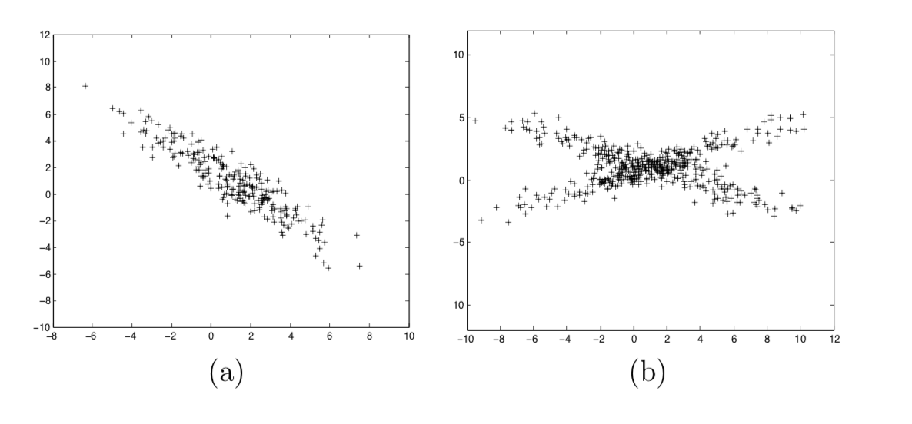

**PC2**

**PC1**

**PC2**

**PC1**

1. **PCA for Face Recognition (Code is in R script, Q4.R)**
2. **Generating Eigenfaces**

**Eigenface 1:**

Subject01



Subject14



**Eigenface 2:**

Subject01



Subject14



**Eigenface 3:**

Subject01



Subject14



**Eigenface 4:**

Subject01



Subject14



**Eigenface 5:**

Subject01



Subject14



**Eigenface 6:**

Subject01



Subject14



1. **Facial Recognition**

In order to project the test images against the top eigenfaces, I used cosine-similarity (normalized dot-product) which compares the angle of two vectors. Cosine-similarity is bounded between -1 and 1, and a score of zero means the vectors are orthogonal and thus have no relation. A score of 1 means perfect positive correlation, while a score of -1 means perfect negative correlation.

Score 1 (subject 01 test image vs. subject 01 eigenface 1): -0.9814099

Score 2 (subject 01 test image vs. subject 14 eigenface 1): -0.8720915

Score 3 (subject 14 test image vs. subject 01 eigenface 1): -0.8917421

Score 4 (subject 14 test image vs. subject 14 eigenface 1): -0.9897491

Using these scores we are indeed able to recognize whose face is in each test image. We can see that there is a stronger (negative) relationship between each test image face and their respective top eigenvalue. What is important is not the direction of the relationship, but rather its strength. As stated before, a cosine similarity of 0 indicates orthogonal vectors and therefore no relationship, so we can see that each test subject’s test image is closer to being orthogonal to the other subject’s top eigenface.